CSC 3210

Computer Organization and Programming

Lab 4

Answer Sheet

Student Name: **Asrar Syed**

Section: **022 / CRN: 17915**

Debug through each line of code and explain the register content.

**Write and run a program to evaluate the following expression:**

**AL = (AL – DL) + CL – BL**

**Build Succeeded**

**Line number: 14**

**Instruction: mov AL, 245**

**Register value: EAX = 0080FDF5 | AL = F5 (245 in decimal)**

**Flags: None changed**

**Explanation: Move the value 245 into the 8-bit AL register, i.e. loading the first 8-bits of the EAX register with this value.**

**Line number: 15**

**Instruction: mov BL, 41**

**Register value: EBX = 00A01029 | BL = 29 (41 in decimal)**

**Flags: None changed**

**Explanation: Move the value 41 into the 8-bit BL register, i.e. loading the first 8-bits of the EBX register with this value.**

**Line number: 16**

**Instruction: mov CL, 11**

**Register value: ECX = 009E100B | CL = 0B (11 in decimal)**

**Flags: None changed**

**Explanation: Move the value 11 into the 8-bit CL register, i.e. loading the first 8-bits of the ECX register with this value.**

**Line number: 17**

**Instruction: mov DL, 215**

**Register value: EDX = 009E10D7 | DL = D7 (215 in decimal)**

**Flags: None changed**

**Explanation: Move the value 215 into the 8-bit DL register, i.e. loading the first 8-bits of the EDX register with this value.**

**Line number: 18**

**Instruction: sub AL, DL**

**Register value: EAX = 0080FD1E | AL = 1E**

**Flags: ZR = 0 (Zero Flag) | AC = 1 (Auxiliary Carry Flag)**

**Explanation: AL = AL – DL.**

**1E = F5 – D7 (30 = 245 – 215, in decimal format)**

**Math was done... subtracting DL with whatever was in AL and loading it into AL.**

**Line number: 19**

**Instruction: add AL, CL**

**Register value: EAX = 0080FD29 | AL = 29**

**Flags: PE = 0 (Parity Flag - Odd)**

**Explanation: AL = AL + CL.**

**29 = 1E + 0B (41 = 30 + 11, in decimal format)**

**Math was done... adding CL with whatever was in AL and loading it into AL.**

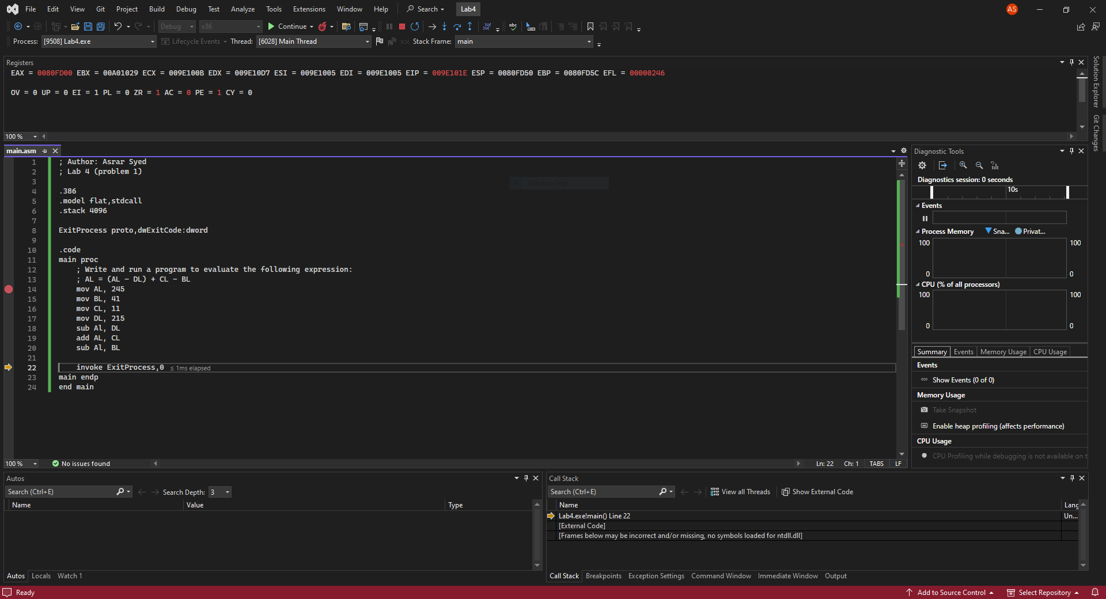

**Line number: 20**

**Instruction: sub AL, BL**

**Register value: EAX = 0080FD00 | AL = 00**

**Flags: ZR = 1 (Zero Flag) | AC = 0 (Auxiliary Carry Flag) | PE = 1 (Parity Flag - Even)**

**Explanation: AL = AL – BL.**

**00 = 29 – 29 (0 = 41 – 41, in decimal format)**

**Math was done... subtracting BL with whatever was in AL and loading it into AL.**